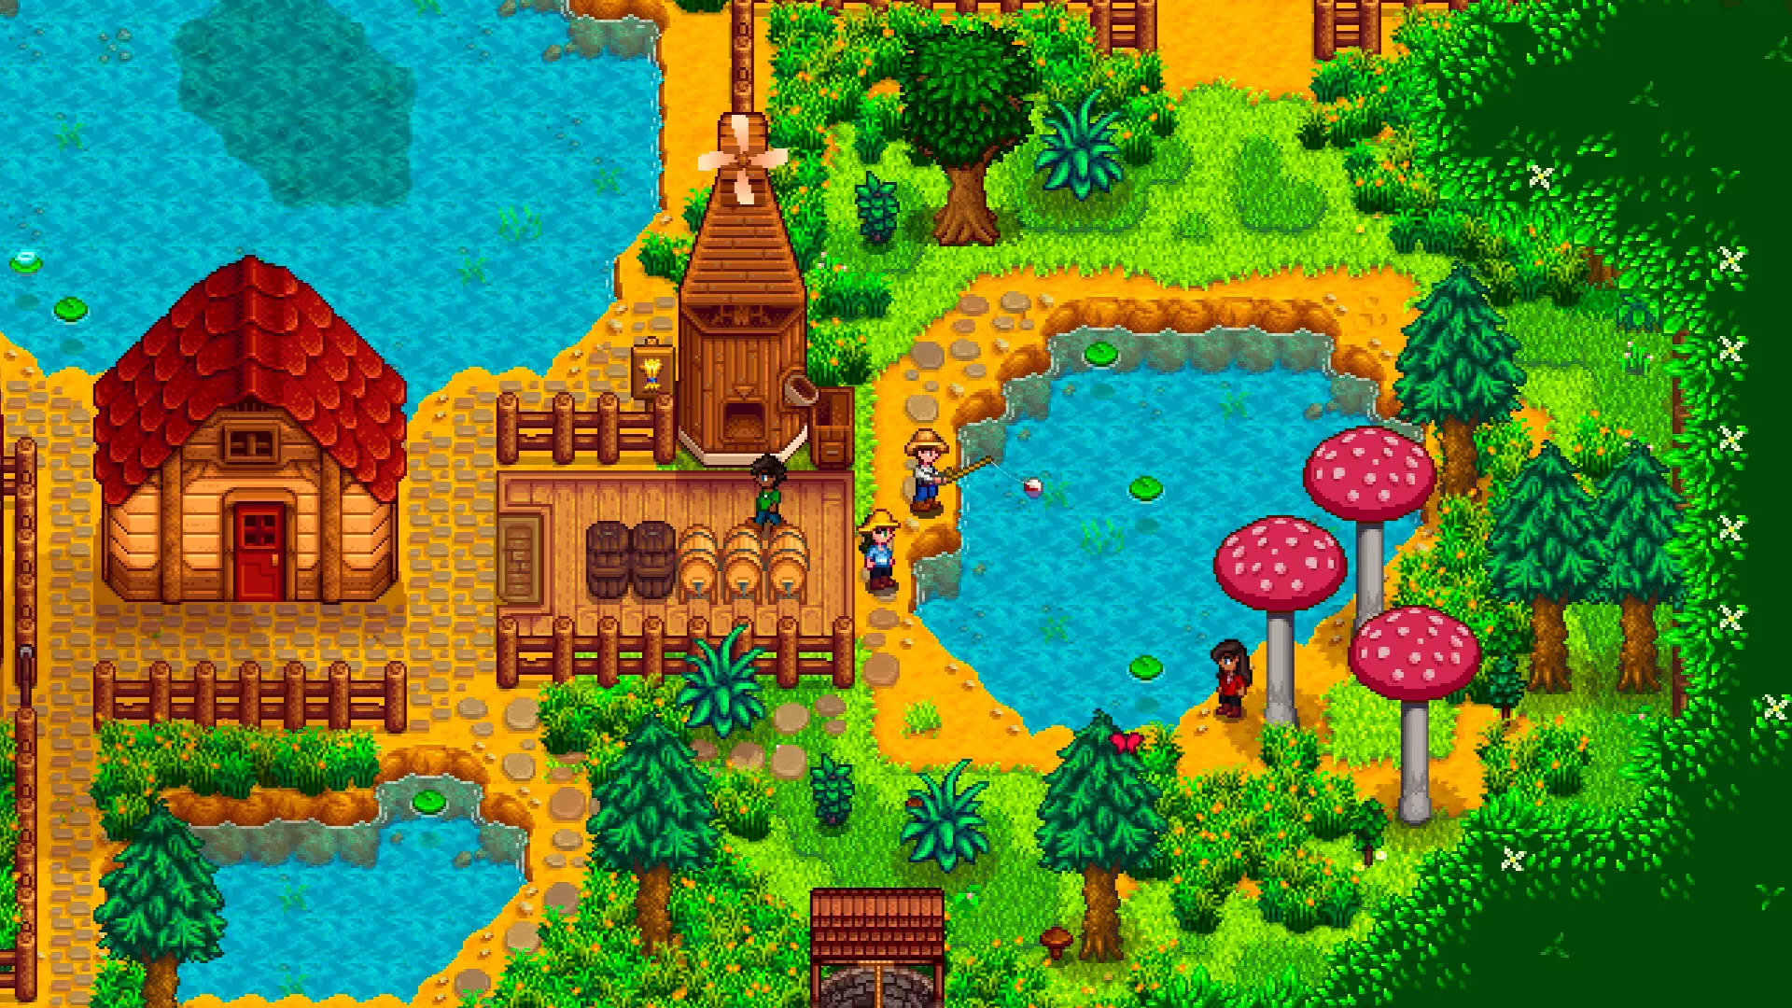

**Plane**

**Mushroom tree:** Cylinder & Sphere / Tapered Cylinder & Sphere

**House:** Box & Pyramid

**Barrel:** Cylinder

I chose to replicate the objects in this Stardew Valley scene. I’ll replicate the house, mushroom trees, and barrel. These are a good idea because they can easily be broken down into component shapes, besides the barrel. The house would consist of a box and a pyramid. The mushroom trees could be a cylinder and a sphere, or a tapered cylinder and sphere. The barrel would just be a cyclinder. Of course there will also be a plane in the scene to ground all objects.

I’m not entirely sure how I will carry out the overall scope of the work, but I’m sure I can do it. I’ll learn how to create those basic shapes before continuing. They don’t seem too complicated, so I have hope!